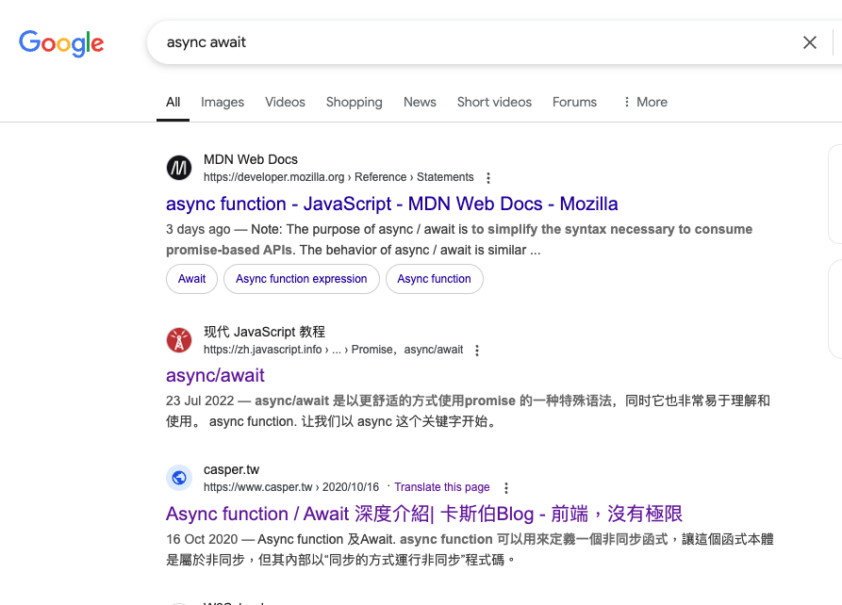

1. [Async function / Await 深度介紹| 卡斯伯Blog - 前端，沒有極限](https://www.casper.tw/development/2020/10/16/async-await/)
2. [Promise - JavaScript | MDN](https://developer.mozilla.org/en-US/docs/Web/JavaScript/Reference/Global_Objects/Promise)
3. [Promise.all() - JavaScript |分子動力學](https://developer.mozilla.org/en-US/docs/Web/JavaScript/Reference/Global_Objects/Promise/all)